IE 10 Browser settings for HTML5 version :-
In Internet Options Security Tab Trusted sites Sites,
Add respective Domain name e.g. cm.stpgate.com :-
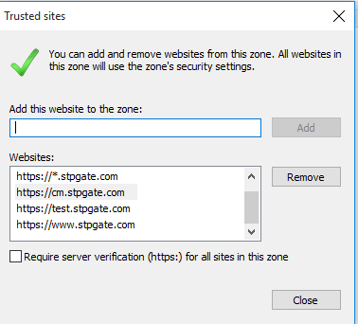

In Internet Options Security Tab Trusted sites Custom level…,
